How to Implement 3rd Party Authentication with Auth0

Requirements:
- Have a website hosted through a cloud provider such as Microsoft Azure and an optional custom domain name through a provider such as GoDaddy
- Access to local and web codebase through GitHub or another service to make changes in the code for this website and authentication procedures
- Have an account set up with Auth0 already
- Access to an IDE of some sort such as Visual Studio Code
- Basic knowledge of React, HTML, CSS, JS, how to make changes to a local repository with GitHub and push changes

Part 1 – Create new application in Auth0 and fill in necessary information
- Log into your Auth0 account that you setup and then go to the side menu and select Applications and then Applications again from the drop-down:
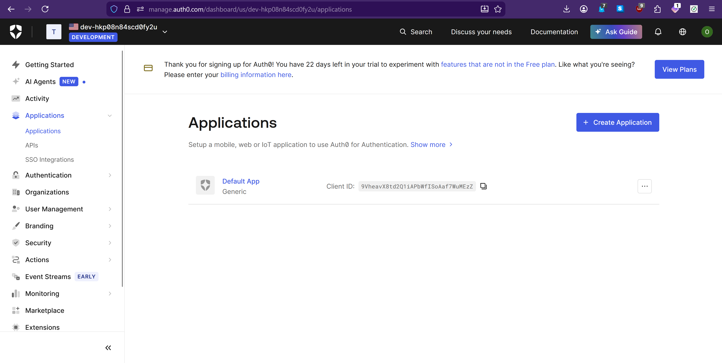
- Click on the button that says + Create Application and then you’ll see a screen like the one below. You’ll want to add the name of your application here and then choose the application type as a Single Page Web Application since we’ll be using this for our React application that is a static web page. Then click Create.
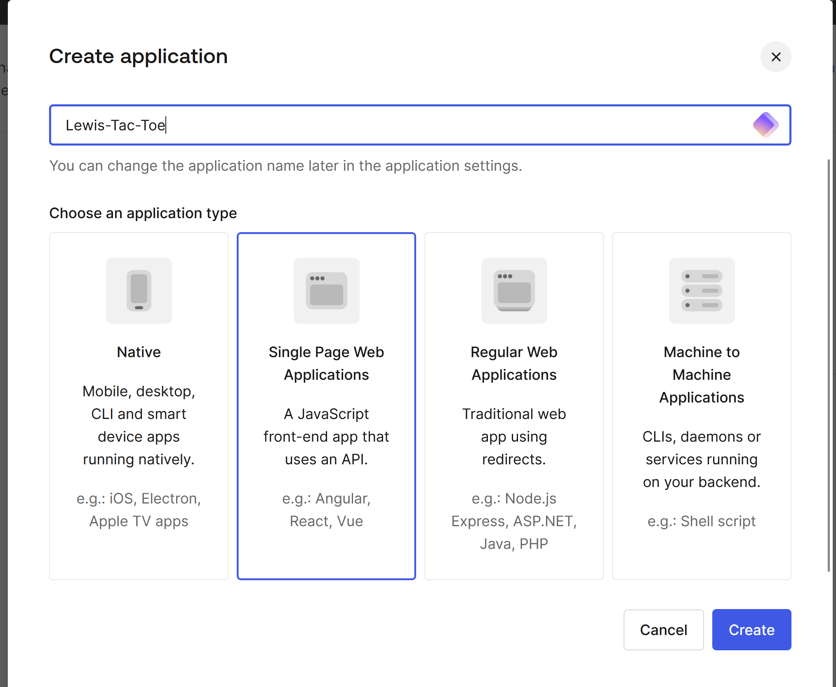
- Now you’ll see a new screen popup. You want to navigate to the settings option and verify that the name is correct and then keep track of the domain, client ID and client secret as you scroll down the page and maybe put those in a separate location on your computer for now in a file just in case.
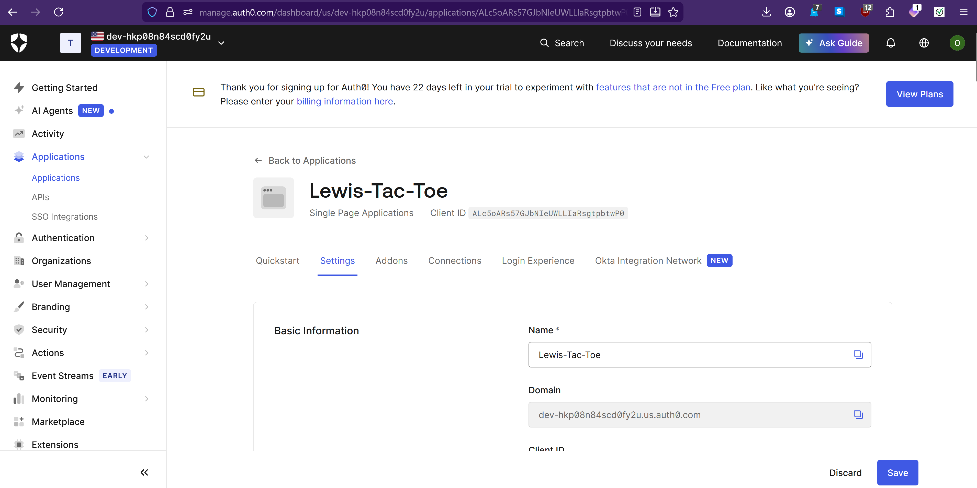
- A little further down the page here you’ll see some blank spaces for things like Application Login URI, Allowed Callback URLs, Allowed Logout URLs, Allowed Web Origins, and Allowed Origins (CORS). You need to fill in all of these boxes with the website you are using Auth0 for. In my case, the website I am working with uses a custom domain name called lewistactoe.lewisunivcs.com and it was originally made on Microsoft Azure as a different name that was automatically assigned. I want to fill in the boxes with my custom domain name which should look something like this:
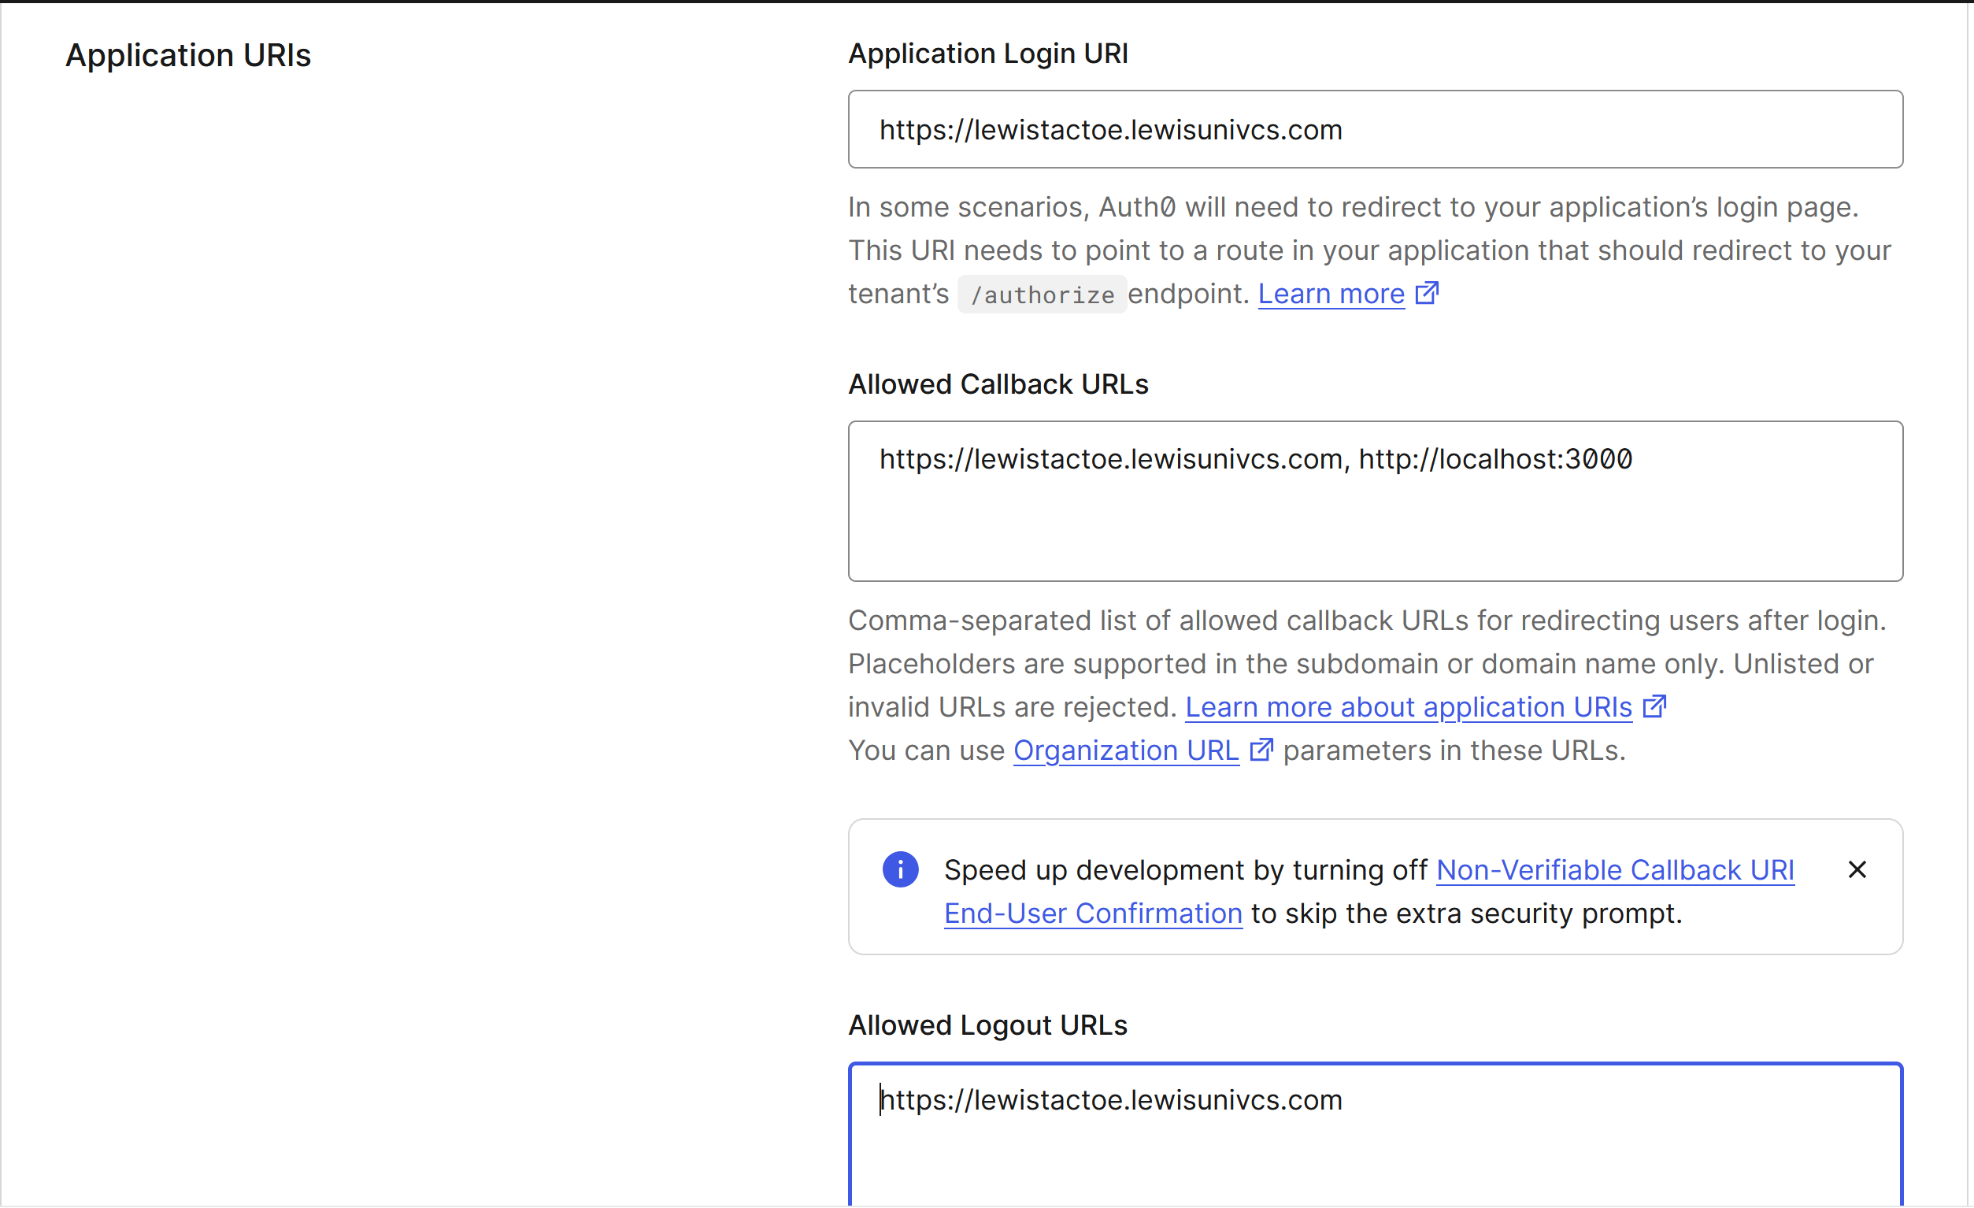

**NOTE: I also added http://localhost:3000 here in the Allowed Callback URLs as well. I am only doing this temporarily for local testing purposes. If you include this in this box, make sure you take it out after local testing and only add it back in when you need it because it could be a security issue later.

Additionally, for the CORS section, you will also probably see a toggle switch and you’ll need to turn that on as well.

Then click Save
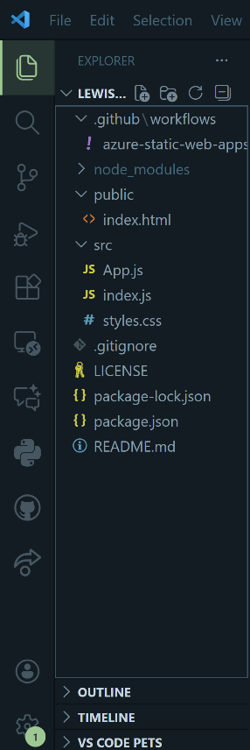

Part 2 – Making updates to the codebase
- Open up your local repository where all your code for this project lives on your machine in an IDE such as VSCode. If you are making a React web application like me, then you should have a similar side panel of files for your code:
- For this tutorial, I am going to assume that everything in these files is already working and has been tested. The only parts we are looking to change are in the files of index.html, App.js, and index.js
- In index.js, you need to add all of this code to your file and then take a closer look at what is underlined in red in the screenshot below:

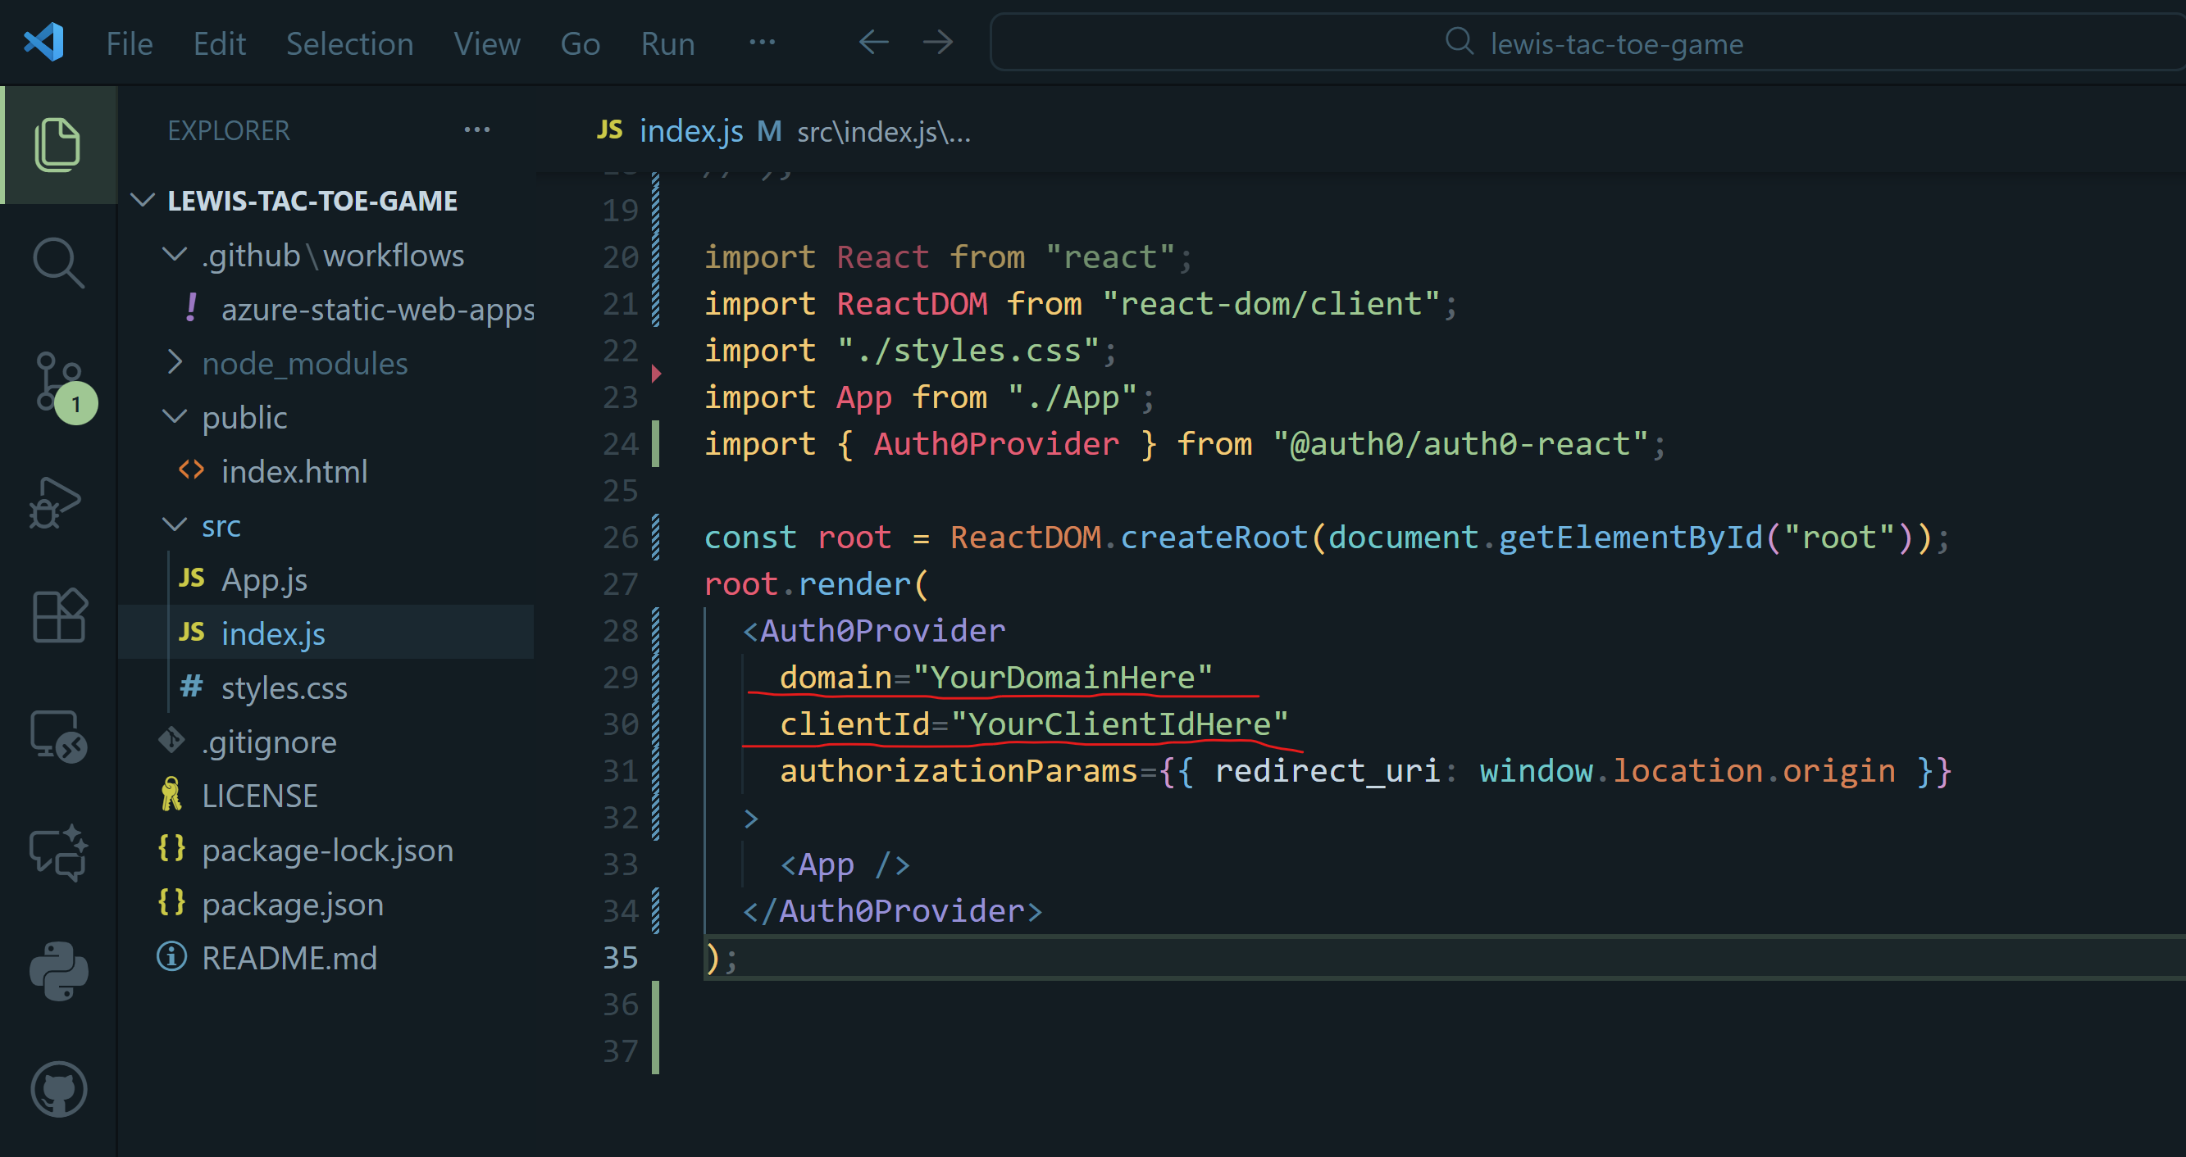

It just says domain=“YourDomainHere” and clientId=”YourClientIDHere”

What you need to do is go back to where you had Auth0 open in the browser and then find the information on the page that looks like this:
Copy your domain and client ID from here and then paste it into the strings listed in index.js in your code and remove what was originally there for those variables.

- Now that index.js is updated, we can move onto App.js. You should have this code and any other additional HTML for the page here like in this example:
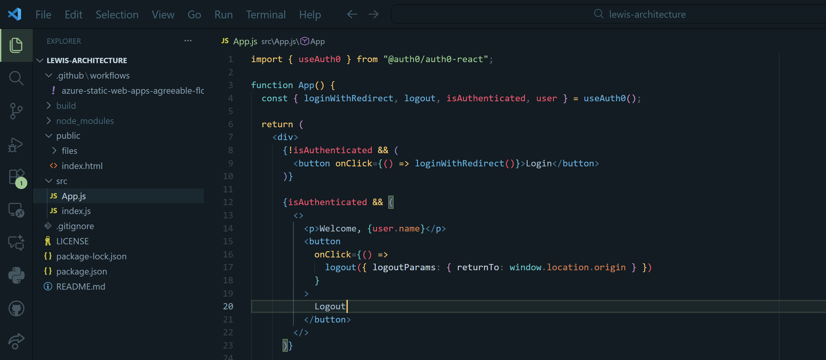

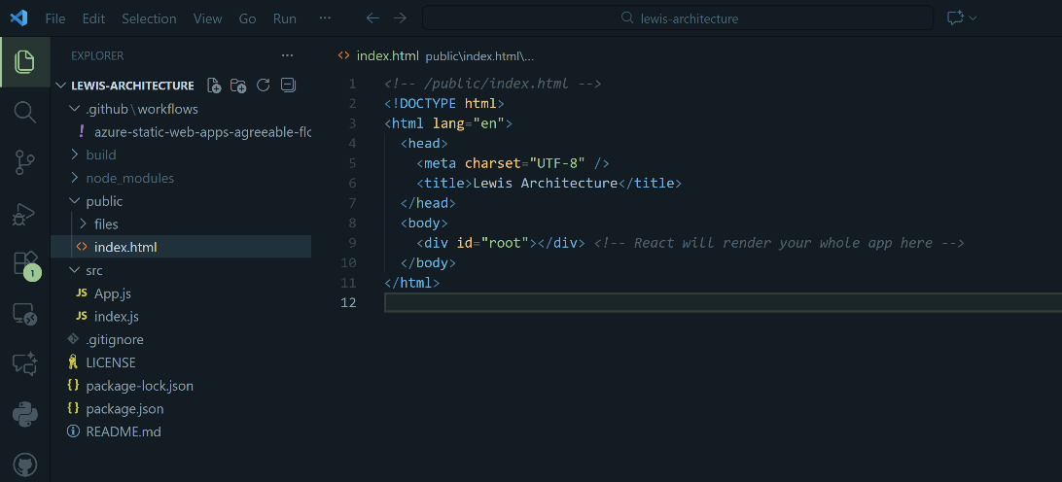
- Once you have done that, we can move onto the index.html file. For this file, all we want to do make sure we have all of this code, but most importantly the <div id=”root”></div> part within the body tags.

Part 3 – Testing the newly added authentication features
- First, we want to test things locally so we’re going to install any additional packages using the terminal (I’m using the PowerShell one inside of VSCode) such as this one:
- Next, if there are no errors, we want to run the following command to build the React app and test it locally:
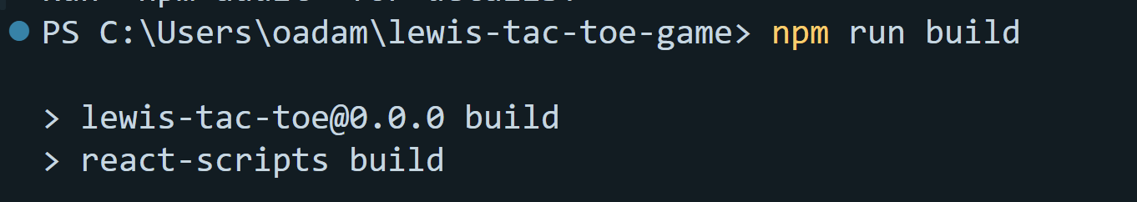
- Then, you may also have to run the following command:
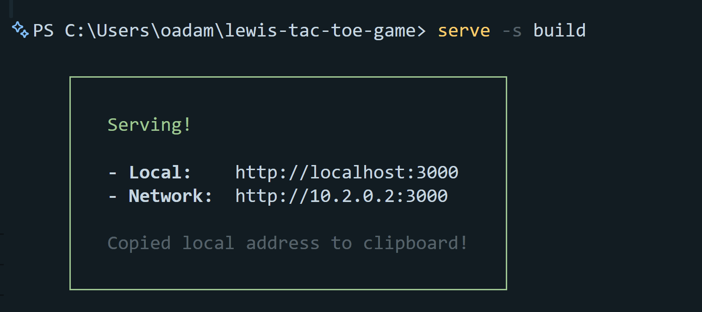
This should soon create a link where you can then click on it to open a browser pointing to http://localhost:3000 and you can see what your application looks like:
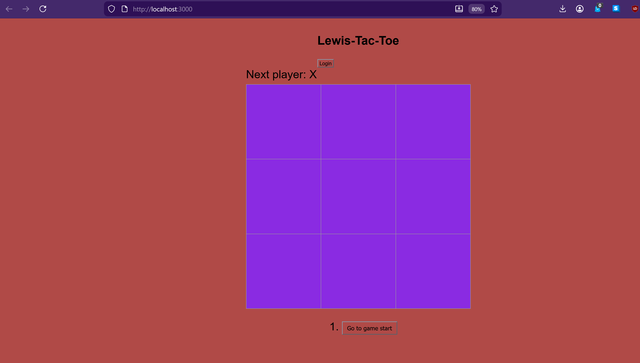
When I click on the login button, I can see a new screen popup that allows me to sign in, sign in with Google, or sign up:
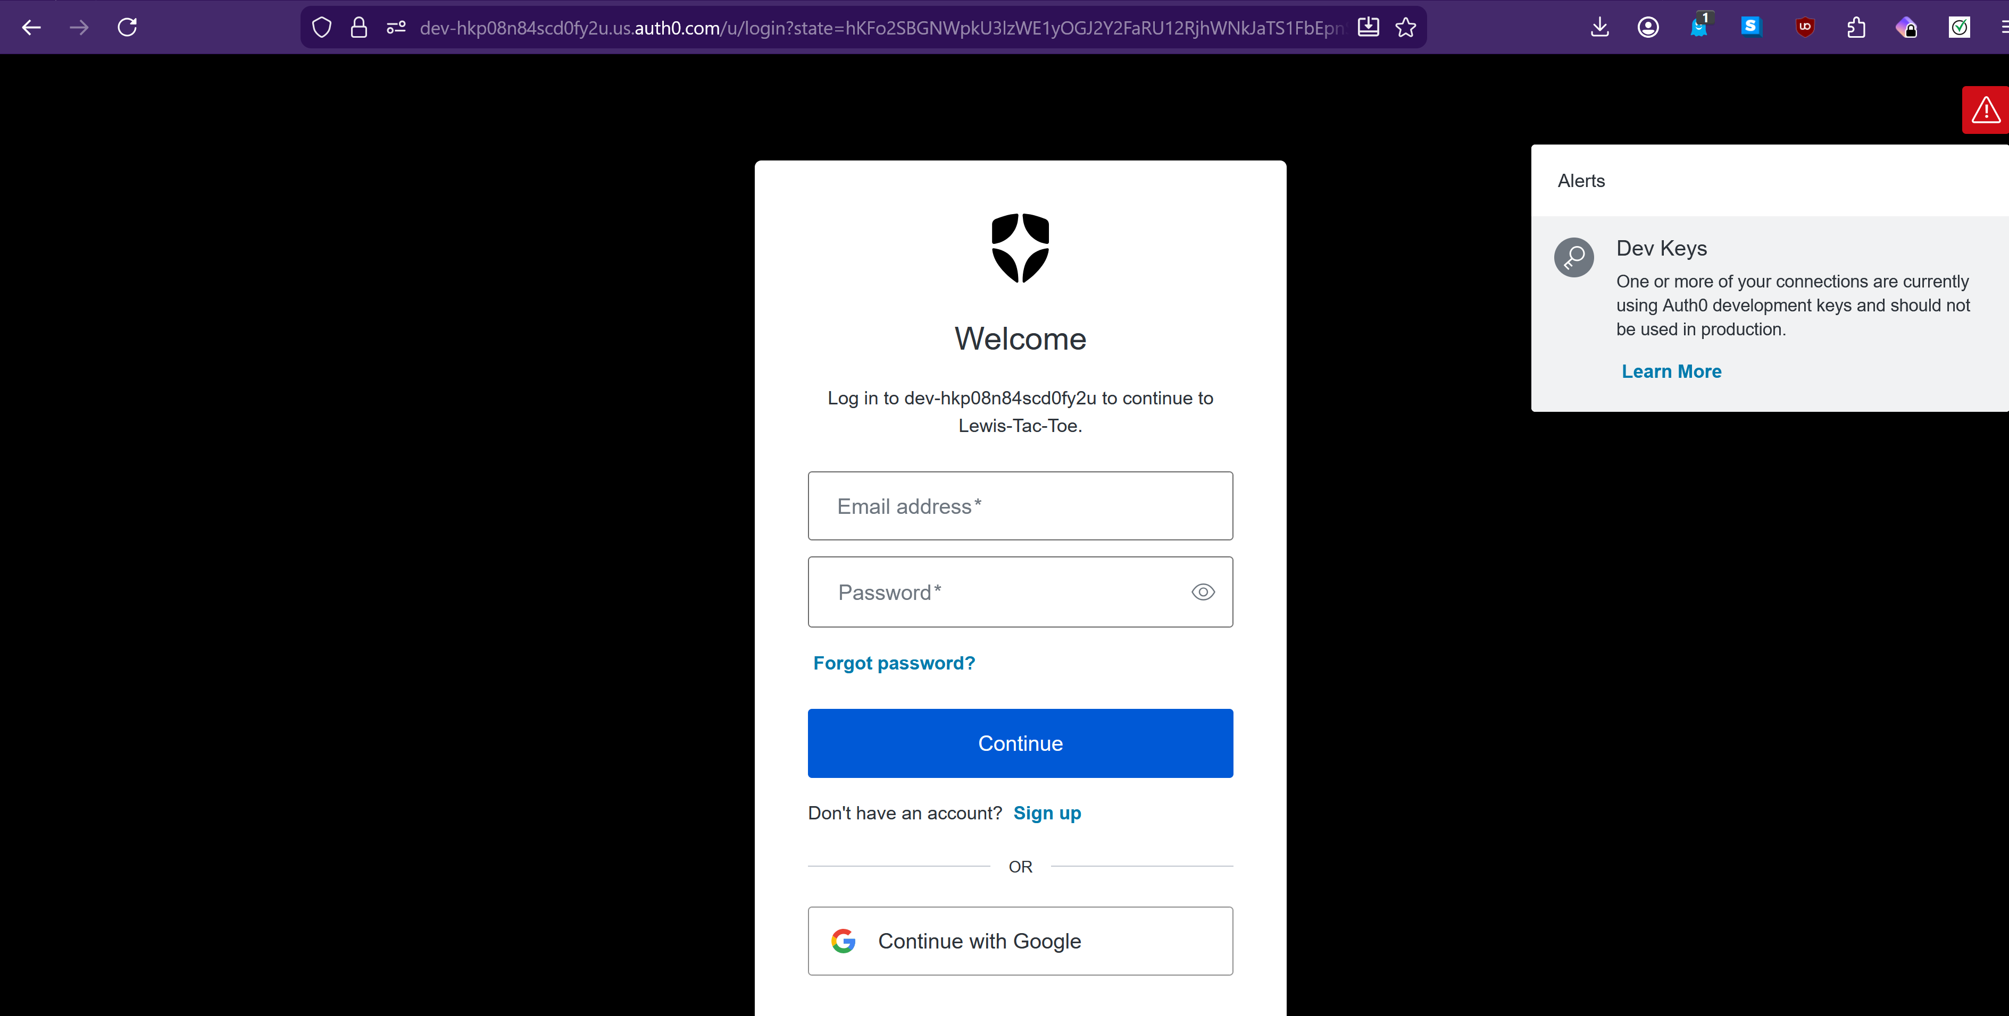
- You can complete any of the following options. I signed up with a Google account and then once that was verified and completed, it transferred me back to the page, but added my name at the top so I know I am now logged in:
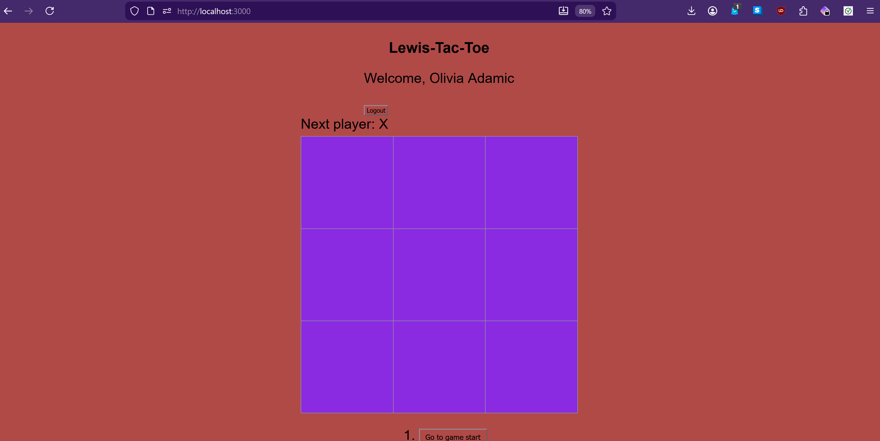
- You may have noticed that warning about the dev keys on the login page. This is something we should absolutely take care of because it poses a big security risk. If you have any keys or secrets involved with any application you are developing, it’s important to make sure they aren’t being exposed publicly such as when you push the code from your local machine to the web. Hackers could easily obtain that information and use it to do malicious things to your site and it could affect your product and your users. However, in our case, it’s okay for us to leave the domain and clientID for now since its just warning us that because we have the option to allow users to login with other services such as Google, we did not provide our own keys for those providers and Auth0 has to use development credentials. This is something we’ll learn how to fix later on. For now, we’re not exposing anything that shouldn’t be there.
- Now, you can push your changes to your repository if you find your testing to be successful. Then once everything is pushed through to your actual website, go to its address and verify that the same changes are there. If that looks all good then you have completed this tutorial of how to add 3rd party authentication with Auth0!

